**DAILY ONLINE ACTIVITIES SUMMARY**

|  |  |  |  |  |  |  |  |  |
| --- | --- | --- | --- | --- | --- | --- | --- | --- |
| **Date:** | **06/06/2020** | | | | | **Name:** | **Katira Krishna J** | |
| **Sem & Sec** | **8th A** | | | | | **USN:** | **4AL16CS045** | |
| **Online Test Summary** | | | | | | | | |
| **Subject** | | **IOT** | | | | | | |
| **Max. Marks** | | **30** | | **Score** | | | **30** | |
| **Certification Course Summary** | | | | | | | | |
| **Course** | **Hadoop101** | | | | | | | |
| **Certificate Provider** | | | **Cognitiveclass.ai** | | **Duration** | | | **5 hours** |
| **Coding Challenges** | | | | | | | | |
| **Problem Statement: Python program to remove all tuples in a list of tuples with the USN outside the given range.** | | | | | | | | |
| **Status: Completed** | | | | | | | | |
| **Uploaded the report in Github** | | | | | **yes** | | | |
| **If yes Repository name** | | | | | **Krishna_Katira** | | | |
| **Uploaded the report in slack** | | | | | **yes** | | | |

Online Test Details:

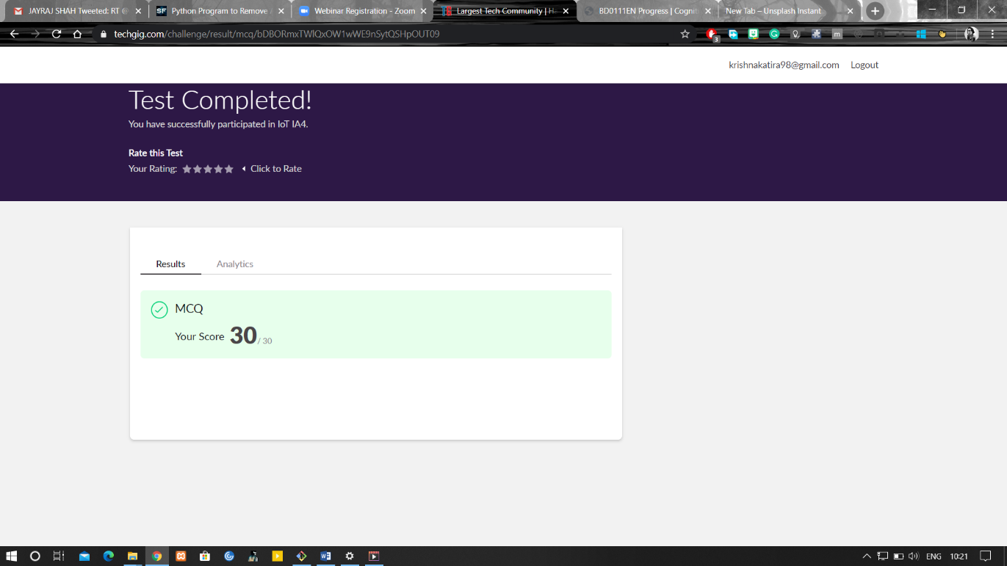

Certification Course Details:

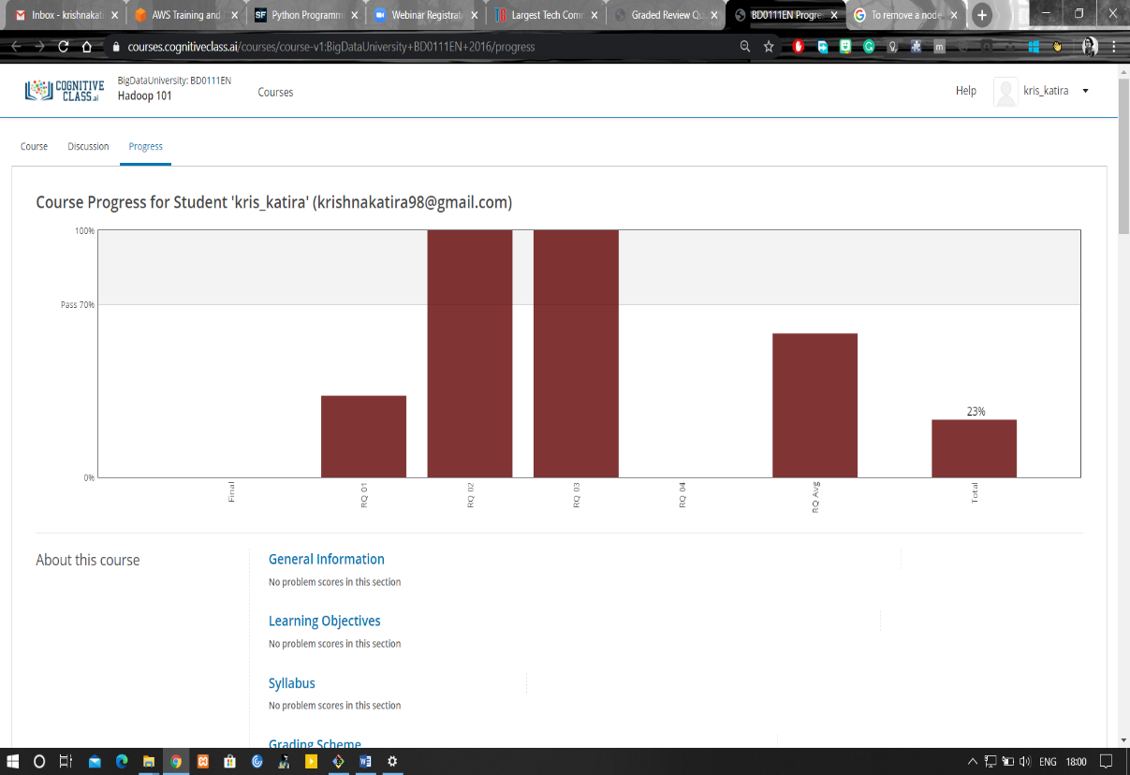

Coding Challenges Details:

**program1**

y=[('a','16CS045'),('b','16CS400'),('c','16CS057'),('d','12CS100')]

low=int(input("Enter lower roll number (starting with 16CS):"))

up=int(input("Enter upper roll number (starting with 12CS):"))

l='16CS'+str(low)

u='16CS'+str(up)

p=[x for x in y if x[1]>l and x[1]<u]

print(p)